| How much money (cash and coins) do you have in your wallet right now? | one 5 dollar bill, 3 one dollar bills. And no coins |
| --- | --- |

The foundation of a market economy is Supply and Demand

| Demands looks at things from the perspective of the | Demands looks at things from the perspective of the consumer |
| --- | --- |

| What is the definition of “Demand”? Make sure to emphasize important words | Quantity of goods and service that a consumer is willing and able to purchase at various prices |
| --- | --- |

| Explain what we mean by “able” when it comes to having effective demand | You must have enough money to make the purchase |
| --- | --- |
| What is something that you want but you do not have demand for because you are not able to afford it? | If you can’t afford something(a private jet, for instance),you don’t have an effective demand for it |

| Explain what we mean by “willing” when it comes to having effective demand | You must be willing to make the purchase for the specified price |
| --- | --- |
| What is something that you can afford but you are not willing to pay the price to purchase it? | If you’re not willing to spend your income on it, you do not have an effective demand for it |



| Keeping in mind how much money you have in your wallet right now, would you be able & willing to purchase waffles with (if you want) butter, syrup and fresh fruit if it was. . . | Yes or No? |
| --- | --- |
| free | Yes |
| $.50 | Yes |
| $1.00 | Yes |
| $1.50 | Yes |
| $2.00 | No |
| $2.50 | No |
| $3.00 | No |
| $3.50 | No |
| $4.00 | No |
| $4.50 | No |
| $5.00 | No |

*Fill in as we take the Zoom polls*

| Price | Quantity Demanded (Purchased) |
| --- | --- |
| $.00 | 31 |
| $.50 | 24 |
| $1.00 | 19 |
| $1.50 | 18 |
| $2.00 | 15 |
| $2.50 | 14 |
| $3.00 | 12 |
| $3.50 | 9 |
| $4.00 | 7 |
| $4.50 | 7 |
| $5.00 | 7 |

*Using almost all of the top half of a piece of paper, draw an L - graph with the vertical axis labeled “Price” and the horizontal axis labeled “Quantity”, plot the points from your demand schedule above and then connect the dots. Take a photo of that graph and then insert that photo below.*

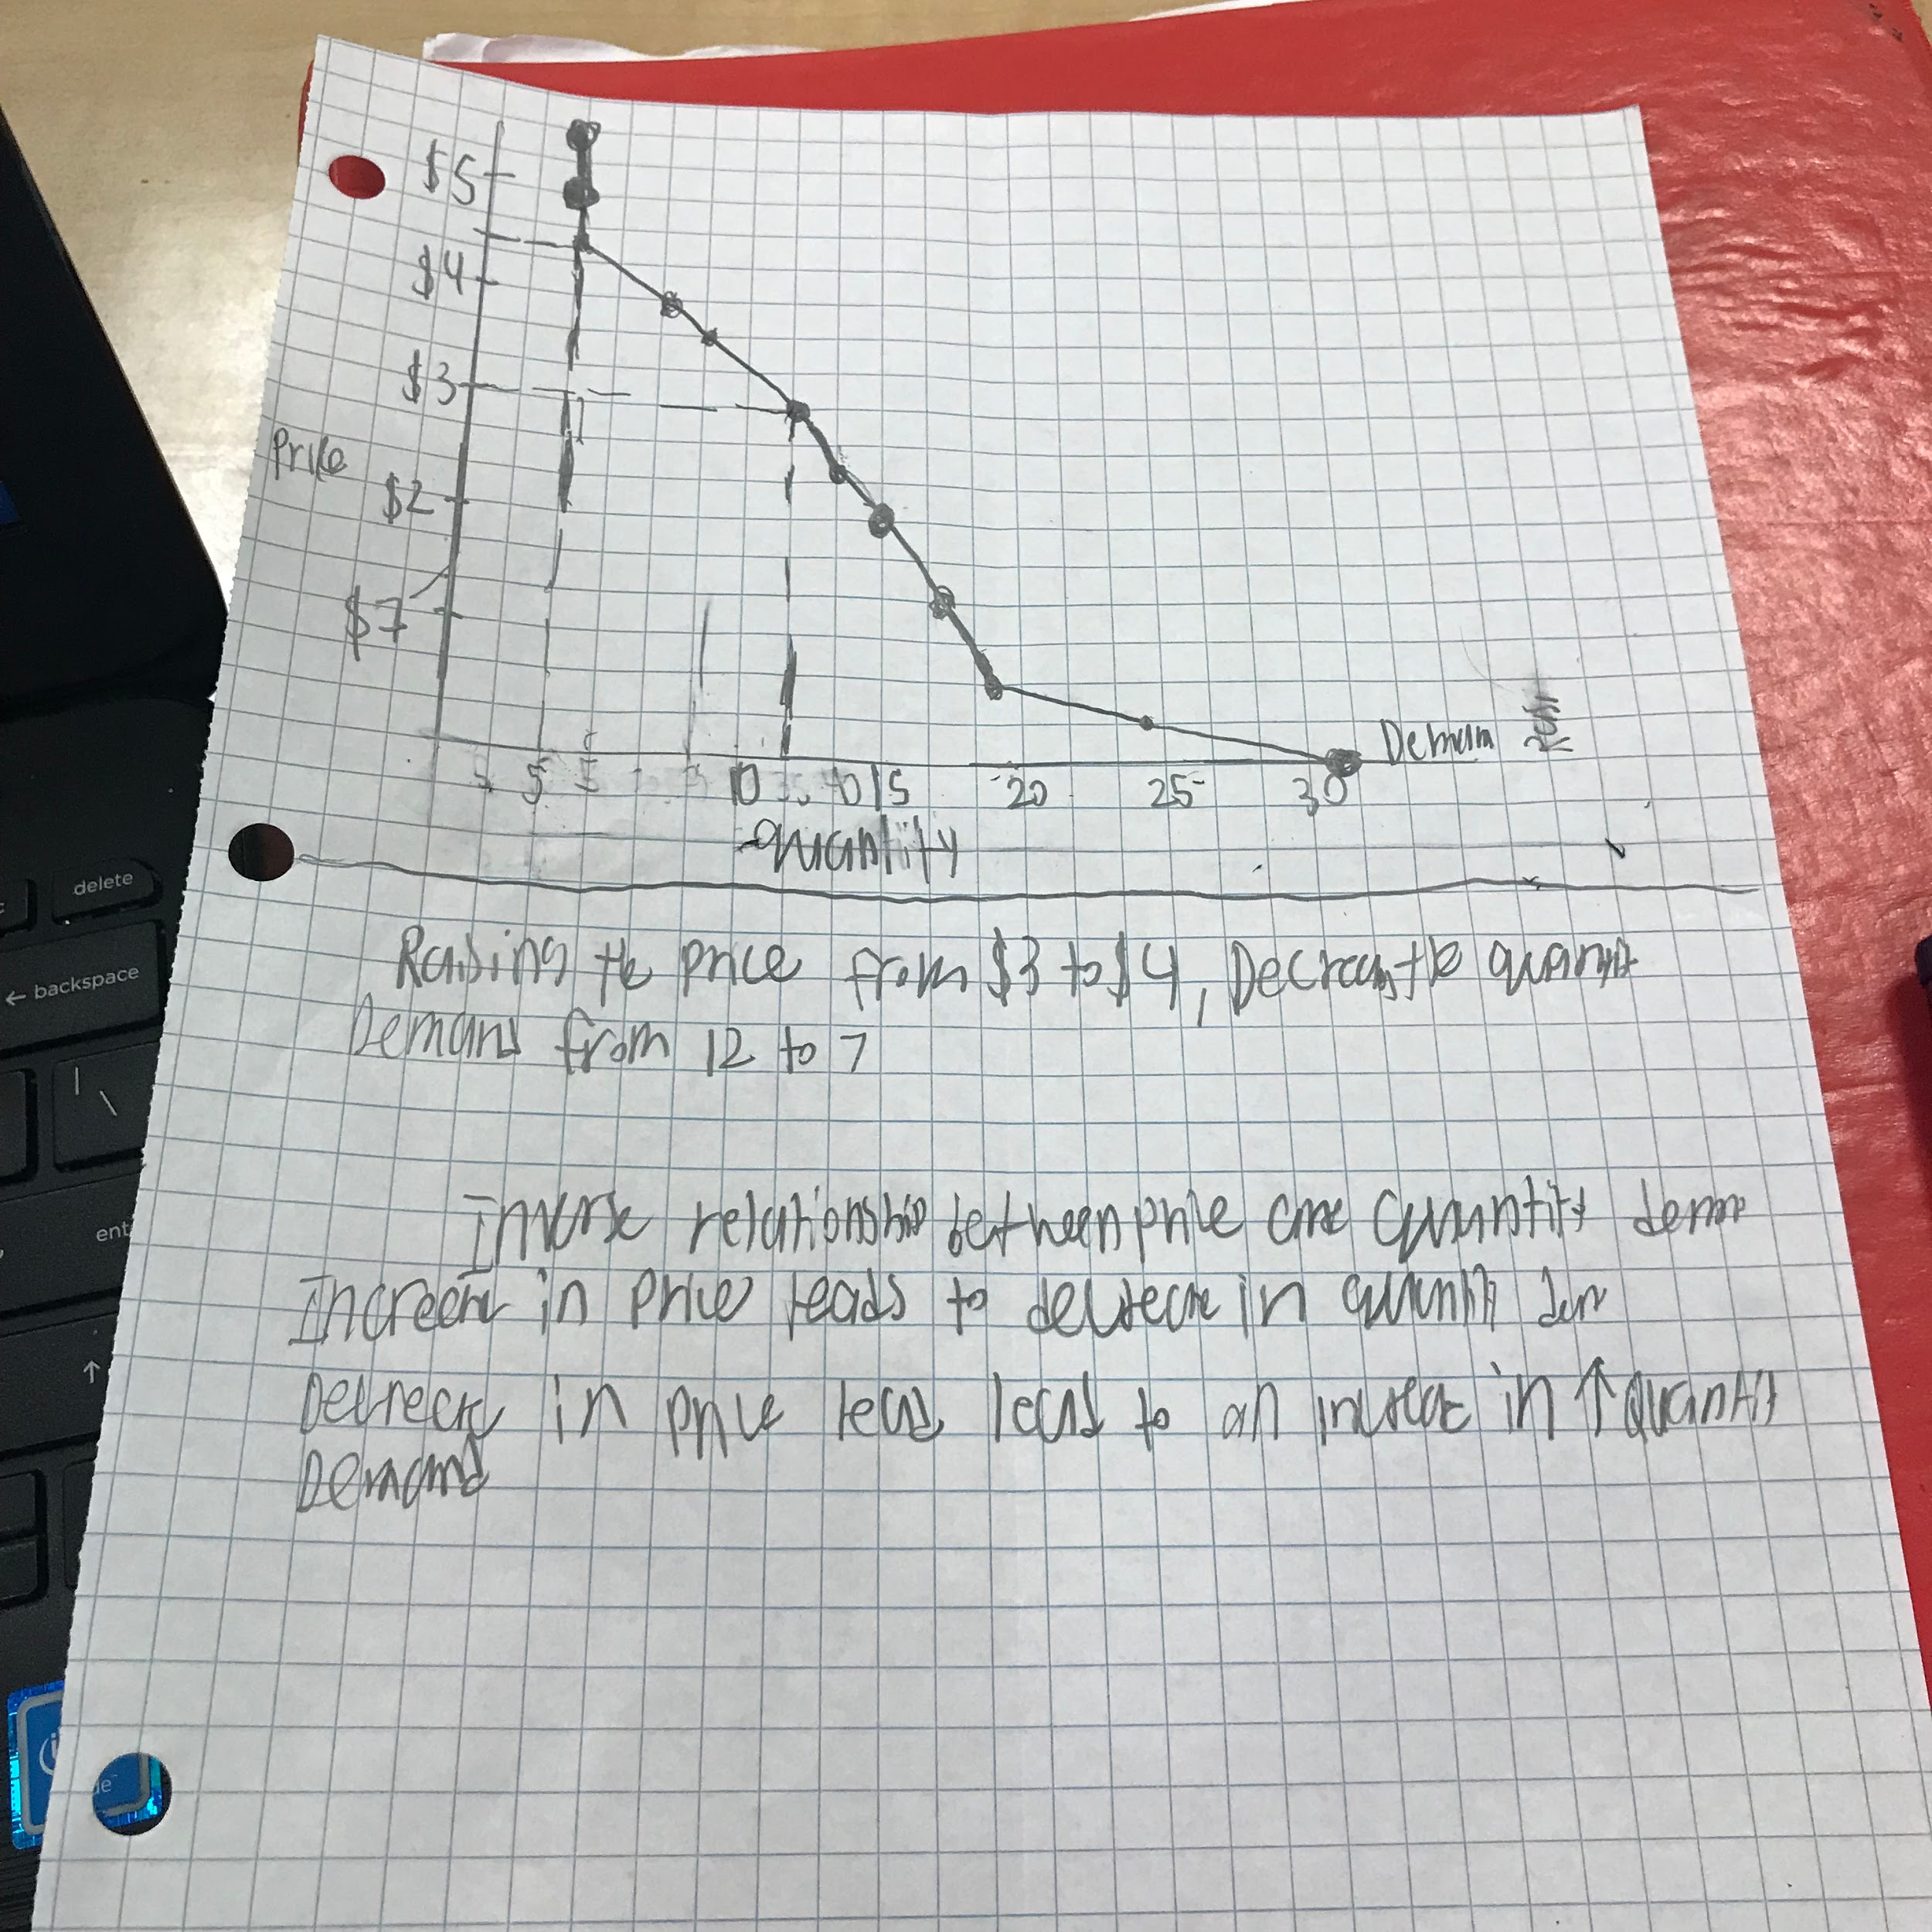

| What is **the law of demand**? | Inverse relationship between price and quantity demanded. Increase in price leads to decrease in quantity demand. Decrease in price leads to an increase in quantity demand |
| --- | --- |

| **AFTER the notes have been submitted and returned to you:  Summarize these notes with 4-5 or more very carefully constructed sentences |  |
| --- | --- |